Class Number Name

Machine number Experiment date Report date

**Experiment topic:**

Experiment 1 Creating and managing the database

Experiment 2 Creating table and entering data

1. **Experiment objectives**
2. Be familiar with the window of SQL Server Management Studio.
3. Master the method of creating database.
4. Master the methods of managing databases.
5. Be familiar with the operation of creating data tables.
6. Master the operation of creating data tables.
7. Master the operation of data input and modification.

**2. Experimental content**

Experiment 1:

1）Open the ‘SQL Server Management Studio’ window, expand the server in the

‘Object Explorer’, then right-click the ‘Database’ node, click the ‘New

Database’ command, finally, the ‘New Database’ dialog box will appear.

2）After entering the database ‘XSCJ’ in the ‘Database Name’ box of the ‘New

Database’ dialog box, you can create a database with the default size by clicking

the ‘OK’ button.

3）Right-click the ‘XSCJ’ database, and select the ‘Properties’ command in the

pop-up shortcut menu, the ‘Database Properties’ dialog box will appear.

4）You can add or delete database files by click the ‘File’ tab, and click the ‘OK’

button to complete the database modification.

Experiment 2:

1）Open ‘SQL server Management Studio’ window，click on the ‘New Query’ button in the ‘standard’ toolbar, and the interface as shown in the figure will appear.

2）In the ‘SQL Editor’ toolbar, click the drop-down button on the right side of ‘Available Database’ to switch the current database to ‘XSCJ’ database.

3）In the query window, input the query statements of creating tables.

4）In the ‘Object Explorer’, unfold the database ‘XSCJ’, right-click the ‘table’ node, and click the ‘refresh’ command in the pop-up shortcut menu, you can see the 3tables that have been created above.

5）Right-click each table and chose the ‘create the first 200 rows’ command in the drop-down menu, and input data for each table, note the input order of the three tables

**3. Experiment procedure**

According to the task, list the task description, the screenshot of the solution process and the screenshot of the running result.

3.1 Task description

The task solution and results

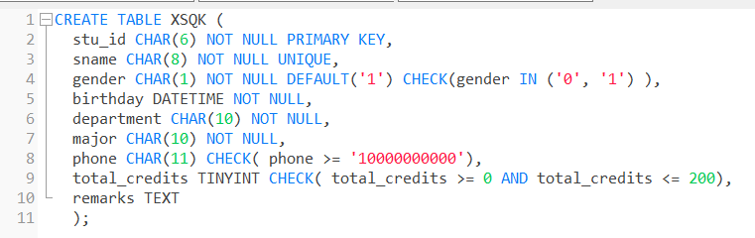

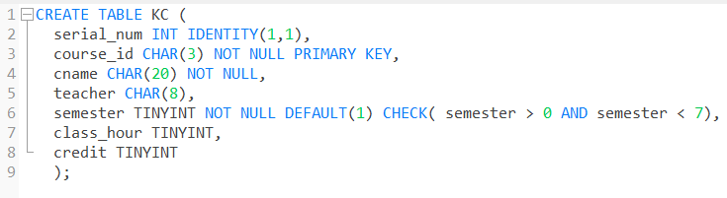

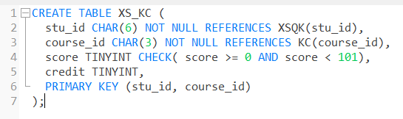

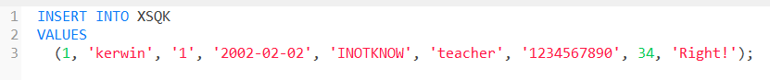

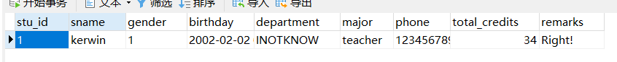

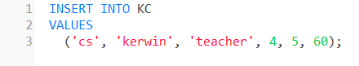

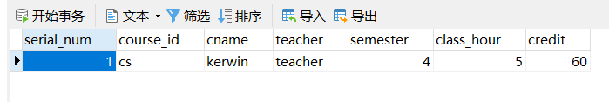



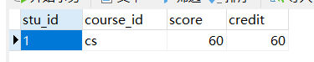

3.2 Debugging analysis

Problems during the debugging process and solutions

Give the program running screenshot

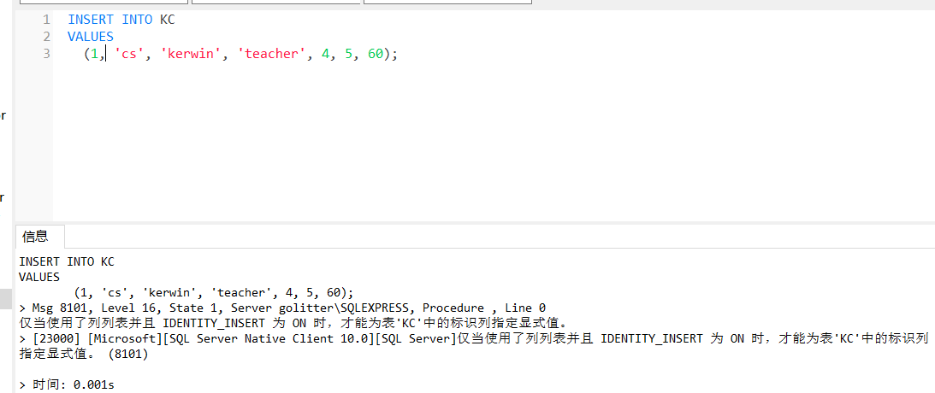

**5. Summary and experience**

**The goal of Experiment 1 is to become familiar with the SQL Server Management Studio window and master the methods of creating and managing databases. Through experiments, I successfully opened the SQL Server Management Studio window and expanded the server in the "Object Explorer" to create a database called "XSCJ". In terms of setting database properties, I have learned that modifications can be made by right-clicking on the database and selecting the "Properties" command.**

**The goal of Experiment 2 is to create a table and input data. Following the steps in the guide book, I successfully created three tables and entered data for each table. Through this experiment, I became familiar with the method of entering query statements to create tables in the query window, and learned to use the commands in the "Object Explorer" to refresh and input data.**

**Throughout the entire experiment, I gained a deeper understanding of SQL syntax and commonly used commands. Through practice, I became familiar with the basic syntax of the CREATE TABLE statement and understood the usage of constraints, such as primary key constraints, foreign key constraints, unique constraints, non null constraints, default constraints, and check constraints. At the same time, I also learned to use the Insert INTO statement to insert data.**

**Overall, this experiment has greatly improved my ability to operate SQL databases. Through practical experience, I have become more familiar with the use of SQL Server Management Studio windows and have mastered the methods of creating and managing databases, creating tables, and inputting data. This will be very helpful for my future work in database management and data operations. Meanwhile, by reflecting on this experiment, I have also realized that there are still some areas that need to be further strengthened and improved in grammar and command usage. In the future, I will pay more attention to practice and learning, and continuously improve my skill level.**